# C1- S4-PRACTICE – GET - INCLUDE

# **PRACTICE 1**

* Display the value of the *GET parameter* with the name ***page*** on the browser.
* If the page parameter is not set, display “home” by default.
* On the header, set the ***href*** attribute of the ***<a>*** elements to redirect to the good URL.

***Example of Result***:

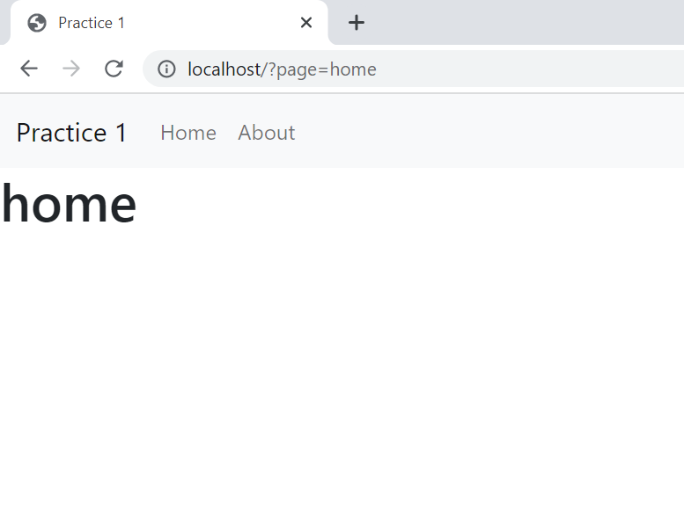

# **PRACTICE 2**

* Use method **$_GET** to get the value of the **page** from the URL
* Include the ***home*** page if the value of the page is ***home*** else include the ***about*** page if the value is ***about***
* If the page parameter is not set, display “home” by default.

**Home Result:**

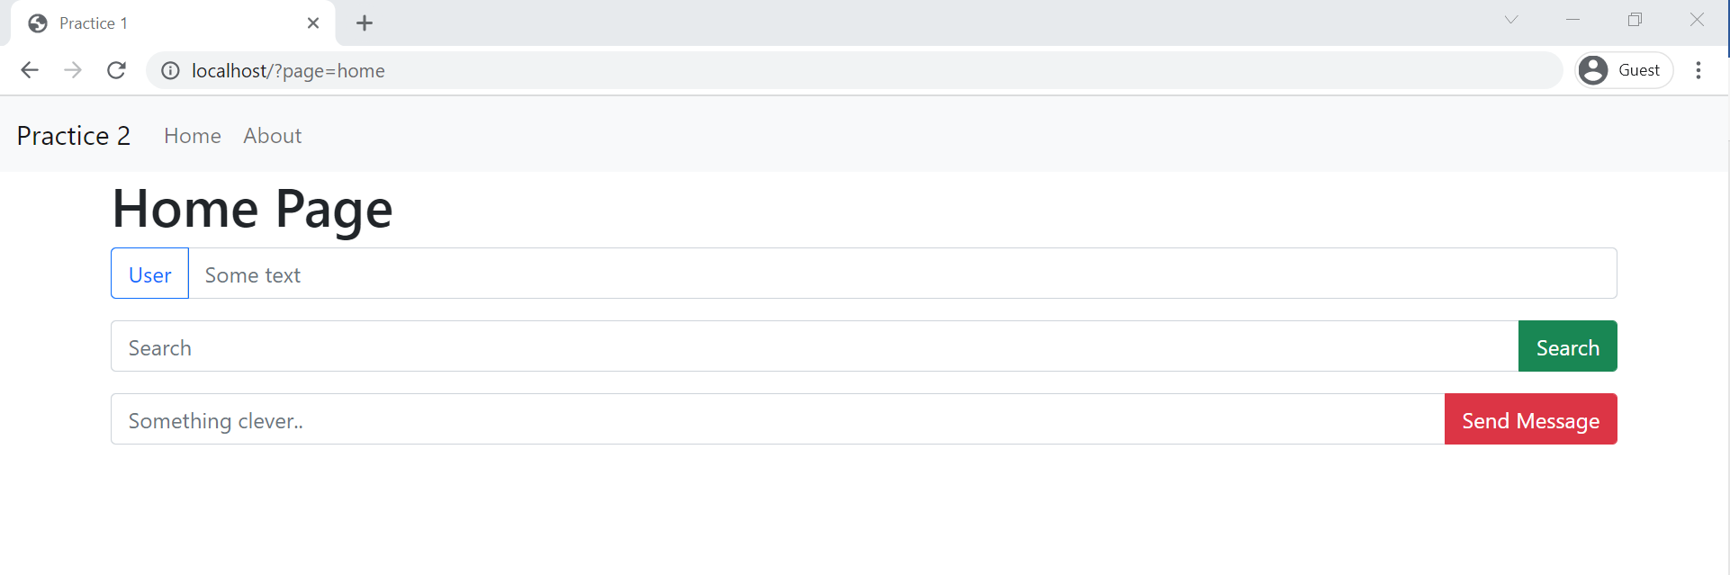

**About Result:**

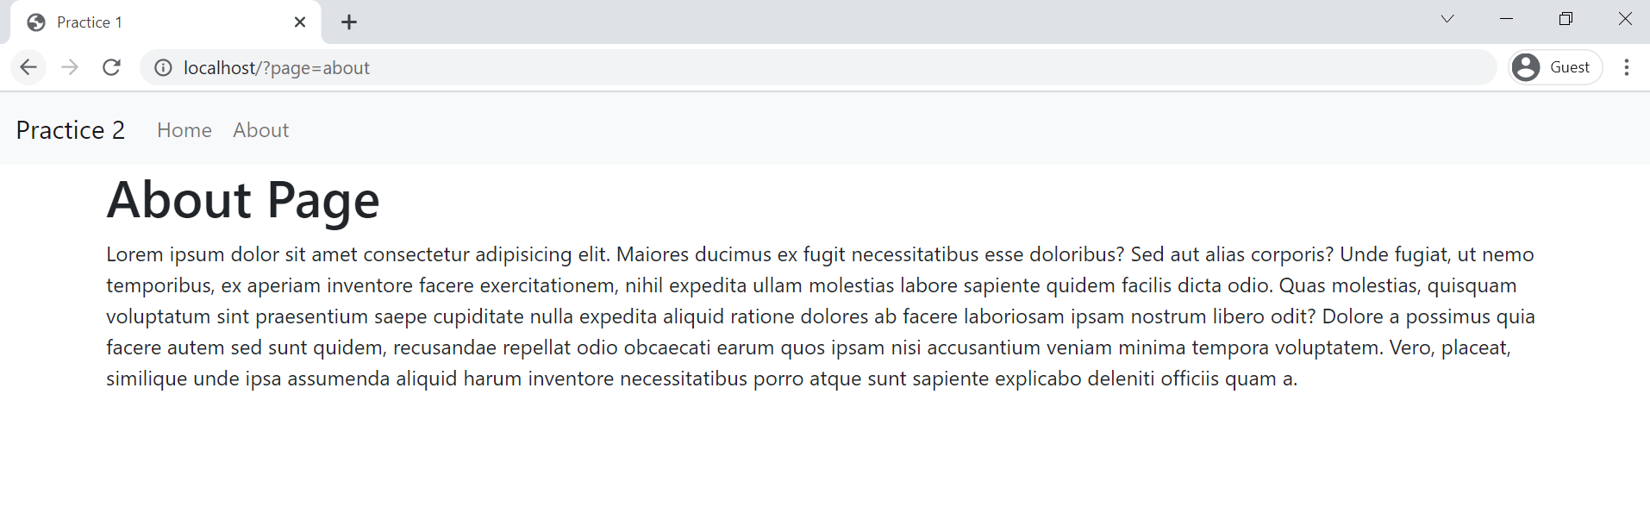

# **PRACTICE 3**

Use method **$_GET** to get value from the URL and display the good page depending on the parameter in the URL.

Example: For the URL <http://localhost/?page=home> the page **home.php** should be included

Pages:

* Home
* About
* Services
* Contact

If page does not exist, for example <http://localhost/?page=something>, the page **404.php** should be displayed:

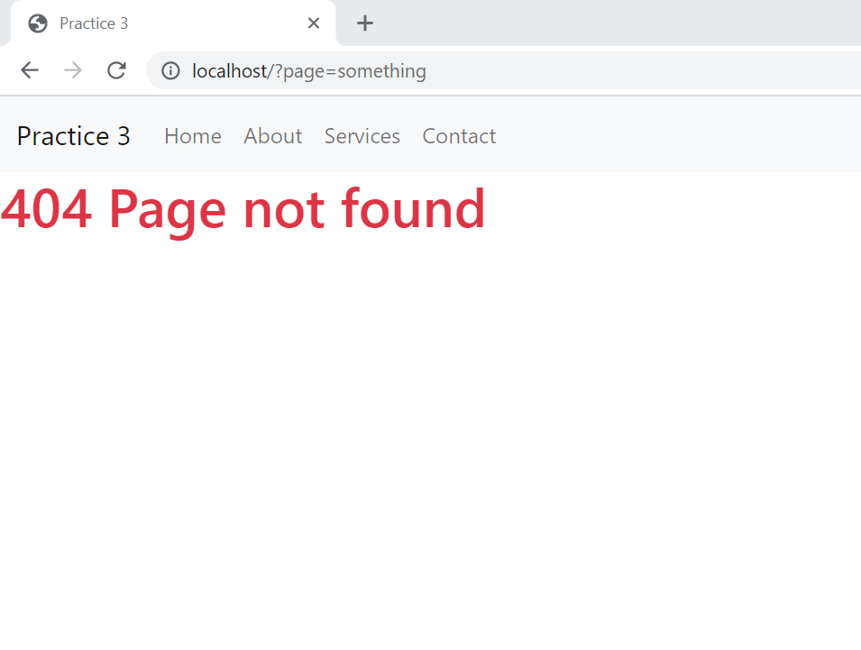

# 

# **PRACTICE 4**

Display on the navbar which page is active

Example: For the URL <http://localhost/?page=home> the page **home.php** should be included ***with active color***

To add the active color, add the class “active bg-danger” to the <a> element

Example:

